Comparative Analysis of Rule-Based Artificial Intelligence Techniques for Car Evaluation Classification

Student Details
- Name:Asinsha.s
- Student ID: 588530
- Module: Artificial intelligence
- Lecturer: Sir Ephin
- Submission Date: 10.05.2026
Table Of Content:
· Introduction
· Literature Review
· Methodology
- 3.1 Dataset
- 3.2 Tools and Technologies
- 3.3 Expert System Implementation
- 3.4 Decision Tree Implementation
- 3.5 Evaluation Metrics
· Results and Discussion
- 4.1 Expert System Results
- 4.2 Decision Tree Results
- 4.3 Accuracy Comparison
- 4.4 Discussion
· Conclusion
· References

Abstract
In recent years, Artificial Intelligence (AI) has become a significant part of decision-making systems. In classification issues, rule-based artificial intelligence algorithms are widely used, as they are characterized by comprehensible decision-making procedures. In this research, we will compare the efficiency of two rule-based artificial intelligence algorithms for determining the acceptability of cars based on the Car Evaluation Dataset provided by the UCI Machine Learning Repository. The first algorithm involves creating a manual expert system utilizing IF-ELSE rules, while the second algorithm employs a Decision Tree classifier.
We have calculated the classification accuracy, precision, recall, F1-score, and performed a confusion matrix analysis to assess the performance of both algorithms. The experiments show that the Decision Tree classifier had greater accuracy than the expert system since it was able to recognize complex patterns within the data set. On the other hand, the expert system was more interpretable due to its manually created rules.
The main conclusions drawn from the research indicate the advantages and disadvantages of rule-based artificial intelligence algorithms in solving classification issues. It can be concluded that Decision Tree algorithms are preferable for dealing with large complex datasets, whereas expert systems still have some advantages.

1. Introduction
Artificial intelligence is among the fastest-growing disciplines in computer science that has been revolutionizing many industries like healthcare, finance, transport, manufacturing, and others. AI refers to computational machines created to imitate human intelligence for activities such as decision-making, prediction, solving problems, and classifying objects. Although several kinds of AI exist, rule-based AI still stands out as one of the oldest types of AI.
A rule-based artificial intelligence system works under the concept of predetermined rules, which enable the computer to take decisions by evaluating certain situations and logical reasoning. Rule-based systems use IF-ELSE constructs and are usually found in expert systems. An expert system is a program designed to replicate the decision-making process of a human expert in a particular field. The main strength of rule-based systems lies in their comprehensibility, which enables users to understand the logic behind a particular decision made.
Evaluation of cars is an essential task within the automotive industry. Consumers and manufacturers evaluate cars depending on various factors such as the buying price, maintenance cost, safety, luggage capacity, and seating capacity. Classification of cars using these factors may help the consumer in deciding whether to buy the car or not.
This study aims at analyzing two different rule-based artificial intelligence approaches applied in car acceptability classification using the Car Evaluation Dataset. The first approach entails building a rule-based expert system manually using IF-ELSE rules. The other approach involves developing a Decision Tree classifier.
The main research question of this study is:
“Which rule-based artificial intelligence approach performs better for classifying car acceptability?”
Goals of this research are:
1.Implementation of an expert system based on rule-based approach utilizing IF-ELSE statements.
2.Implementation of a Decision Tree classifier.
3.Performance analysis and comparison of the two approaches.
4.Strengths and weaknesses analysis of each approach.
This research will contribute to the field of rule-based AI techniques for classifications and also the role of interpretation in intelligence systems.

2. Literature Review
One of the oldest forms of artificial intelligence is rule-based artificial intelligence, which has played an important role in the evolution of intelligent systems. Rule-based intelligent systems make decisions using rules that apply under particular circumstances. As per Russell and Norvig (2021), rule-based intelligent systems are designed to mimic human thinking capabilities.The reason why expert systems gained prominence in the 1980s was due to their ability to provide decision-making support to businesses using automation. Expert systems are made up of a knowledge base and an inference engine, which is used to solve problems within a particular field. According to Jackson (1998), expert systems have high interpretability as their decision-making procedures can easily be understood.However, expert systems also have some disadvantages. One of the problems associated with expert systems is the challenge of maintaining and updating the rules when the system becomes complex. Rules creation may be difficult and may not necessarily be generalized beyond the training set. Moreover, there is a problem associated with reliance on human expertise in rule creation which may sometimes introduce inconsistencies and biases.
Another rule based algorithm is known as Decision Trees. The Decision Tree rule based algorithm classifies data by recursively partitioning features into decision nodes. Decision Tree algorithms such as ID3 were proposed by Quinlan (1986), becoming one of the earliest successful algorithms in machine learning for classification applications. Decision Trees enjoy widespread use owing to their interpretability, efficiency and ability to handle numeric and categorical data.
Unlike Expert Systems, Decision Tree algorithms learn patterns from training data automatically. Han, Kamber & Pei (2012) stated that Decision Trees are excellent classification algorithms because of their simplicity in generating comprehensible structures while achieving optimal predictive performance. The weakness of Decision Tree algorithms is that when exposed to complicated data sets, overfitting may occur.
Many scholars have conducted extensive analysis using artificial intelligence models to analyze cars. The popular Car Evaluation Dataset in the UCI Machine Learning Repository contains categorical attributes relevant to the quality and acceptability of vehicles. Many previous studies have implemented Decision Trees, Naive Bayes, Support Vector Machines, and Neural Networks on the Car Evaluation Dataset.
According to Dua and Graff (2019), machine learning algorithms can be applied to structured datasets to attain accurate results. Nonetheless, interpretation is essential in determining appropriate AI models for application in various areas. Rule-based AI systems are beneficial in areas that require interpretability and transparency in decision-making processes. Compared to deep neural networks, users can track decisions made using rule-based AI models. This transparency increases trust and contributes to the development of ethical AI technologies.
Several literatures reveal numerous advantages of expert systems and decision trees in classification problems. For example, expert systems are easy to understand and interpret, whereas decision trees employ automatic learning and make accurate predictions. This study builds on prior studies by comparing expert systems and decision trees using the Car Evaluation dataset..

3. Methodology

3.1 Dataset

This research project involved the use of Car Evaluation Dataset from UCI Machine Learning Repository.

Car evaluation dataset consists of the following features:

•Price of buying

•Price of maintenance

•Number of doors

•Capacity of passengers

•Size of luggage boot

•Safety level

Class attribute in the dataset can be classified into one of four categories:

•Unacceptable (unacc)

•Acceptable (acc)

•Good (good)

•Very good (vgood)

Classification of data was chosen for this research due to the categorical nature of attributes.
3.2 Tools and Technologies

The code was written in the Python programming language within the Google Colab environment. The following Python libraries were used for data preparation, modelling, evaluation, and visualisation purposes:

Libraries used are:

•Pandas

•NumPy

•Matplotlib

•Scikit-learn
3.3 Expert System Implementation

In the initial part of this project, a rule-based expert system was created that used IF ELSE statement. Rules were created by experts to classify the cars.

Some examples of rules can be:

•IF safety=low THEN unacceptable

•IF buy-price=low & safety=high THEN acceptable

•IF persons=2 THEN unacceptable

It was totally based on human knowledge without learning anything from data.

3.4 Decision Tree Implementation

Decision Tree classifier was another algorithm that was used. It was implemented using Scikit-learn. First of all, the dataset was encoded using LabelEncoder as Decision Trees can process only numerical values.

Then the dataset was split into training and test parts in the ratio 70/30. The Decision Tree was trained using the training part and tested on the test one.

The Decision Tree learned classification rules from data patterns on its own.

3.5 Evaluation Metrics
The performance of both algorithms evaluated using following metrics:

Accuracy
Accuracy measure percentage of correct classified instances.
Accuracy Formula:
Accuracy = (TP + TN) / (TP + TN + FP + FN)

Precision
Precision measure the proportion of positive predictions that was correct.

Recall
Recall measure the proportion of actual positive cases that correctly identify

F1-score
The F1-score combines precision and recall into a single metric.

Confusion Matrix
confusion matrix is used to visualise classification performance and to identify prediction errors.

4. Results and Discussion

4.1 Expert System Results
The expert system was able to classify the cars based on rules created by people. The model was able to achieve decent accuracy because the rules were not complex.
The expert system had high interpretability as the reasoning process could be easily interpreted by users. However, the expert system faced difficulty in capturing complex relationships between the attributes.

4.2 Decision Tree Results
The Decision Tree had better accuracy in classifying vehicles than the expert system because the Decision Tree automatically discovered connections between attributes and produced classification rules based on them. It was able to classify vehicles more accurately due to the systematic analysis of the attributes' combinations.

4.3 Accuracy Comparison
This is because the decision tree method adapted to the pattern of the data set. The problem with the expert system was that it depended on rules created by humans, which could not cover all possibilities.

4.4 Discussion
Based on the results of the experiment, it is clear that Decision Trees are superior to expert systems developed by people in classification problems with structured data.
Nevertheless, the expert system was superior in terms of interpretability. Because the rules were created by humans, they could be easily understood by users. It is crucial for applications where interpretation is necessary.
Moreover, scalability became evident in the use of the Decision Tree classifier. As the dataset grows larger and becomes more complex, the development of rules manually becomes complicated. Machine learning methods, such as decision trees, allow avoiding unnecessary work.
Still, the disadvantage of decision tree algorithms is that they are subject to overfitting when the model gets too complicated. The problem can be solved by proper parameters adjustment and pruning.
As per the results of confusion matrices' analysis, it became apparent that mistakes in classification were mainly made between acceptable and good cases. This suggests that certain classes share common features, making them hard to classify.
The outcomes of the current research indicate that both rule-based artificial intelligence approaches are quite useful. Expert Systems can be used for simple decisions, while Decision Trees will be the right approach to obtaining better results.
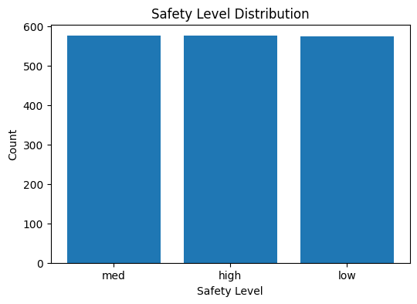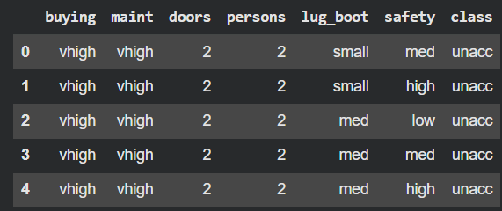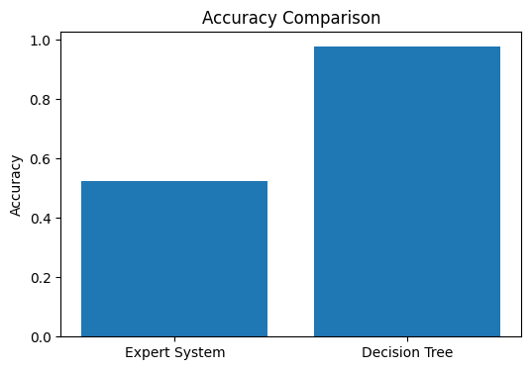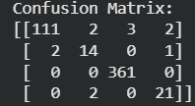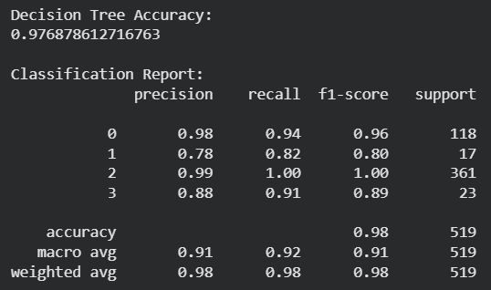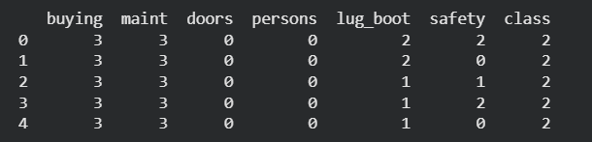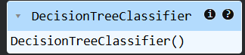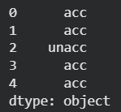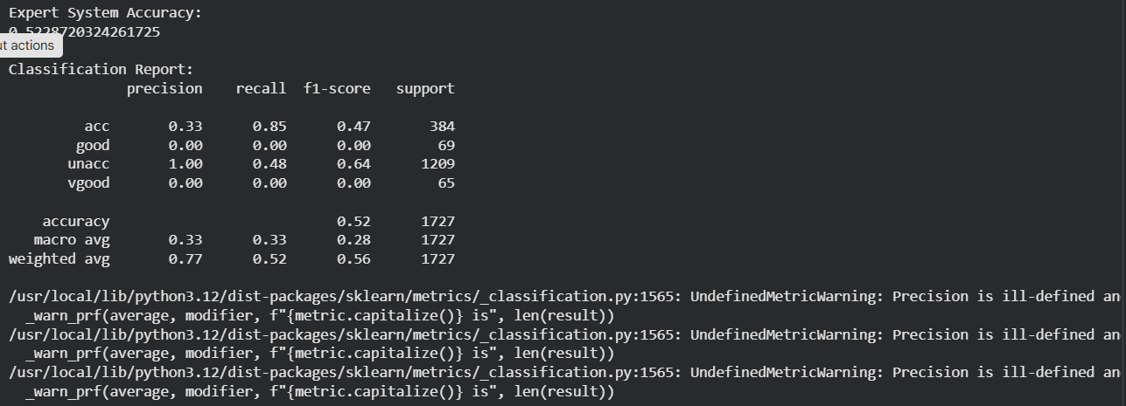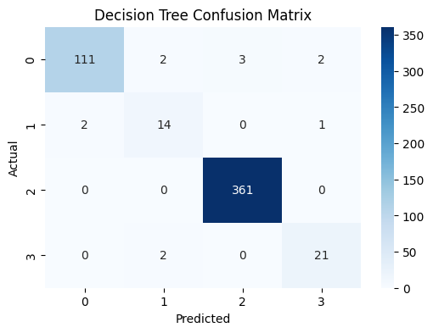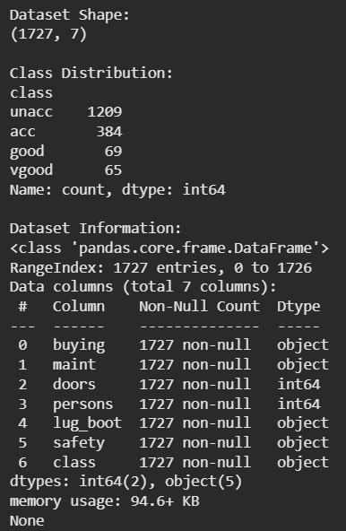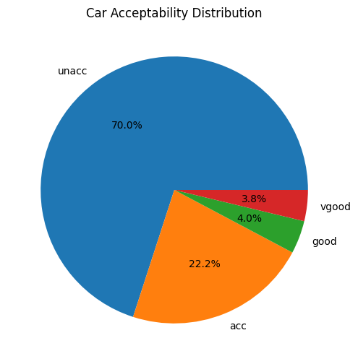

5. Conclusion
This paper presented a comparison between two artificial intelligence methods based on rules for determining whether a car is acceptable through the Car Evaluation Database. The first method consisted of an expert system with handcrafted IF-ELSE rules, whereas the second method used a Decision Tree classifier.
It was observed that the Decision Tree classifier was more accurate than the expert system at classifying cars' acceptability. This happened due to the fact that the Decision Tree algorithm could independently discover data trends and patterns, while the expert system relied on predefined rules only.
While the Decision Tree was more effective in predicting outcomes, the expert system had better interpretability and simplicity features. This characteristic of expert systems makes them indispensable in domains where Explainable Artificial Intelligence is required.
Rule-based artificial intelligence methods have proven to be vital when solving classification problems. Possible directions for further investigation include hybrid AI solutions, other machine learning algorithms, and bigger datasets.

6. References
Dua, D. and Graff, C., 2019. UCI Machine Learning Repository. University of California, Irvine.
Han, J., Kamber, M. and Pei, J., 2012. Data Mining: Concepts and Techniques. 3rd ed. Waltham: Morgan Kaufmann.
Jackson, P., 1998. Introduction to Expert Systems. 3rd ed. Harlow: Addison Wesley.
Quinlan, J.R., 1986. Induction of Decision Trees. Machine Learning, 1(1), pp.81–106.
Russell, S. and Norvig, P., 2021. Artificial Intelligence: A Modern Approach. 4th ed. Harlow: Pearson.
Scikit-learn Developers, 2025. Scikit-learn Documentation. Available at: https://scikit-learn.org/ [Accessed 10 May 2026].
UCI Machine Learning Repository, 2025. Car Evaluation Dataset. Available at: https://archive.ics.uci.edu/ml/datasets/car+evaluation [Accessed 10 May 2026].

